Project Initialization and Planning Phase

Date | 01 july 2026
Team ID | xxxxxx
Project Name | OptiCrop: Smart Agricultural Production Optimization Engine
Maximum Marks | 3 Marks

Define Problem Statements (Customer Problem Statement Template):

Modern agricultural production faces escalating challenges due to climate change, soil degradation, resource constraints, and an exponentially growing global food demand. Traditional farming still relies heavily on intuition and experience-based decision-making, which often fails to achieve optimal crop selection or efficient resource utilization. Without data-driven insights, farmers struggle to accurately align complex soil macronutrients-specifically Nitrogen (N), Phosphorus (P), and Potassium (K)—alongside volatile environmental variables like temperature, humidity, pH values, and unpredictable rainfall with the specific needs of different crops. This mismatch results in suboptimal crop yields and significant resource waste. To overcome these inefficiencies, there is a critical need for an automated, data-driven system like OptiCrop that leverages machine learning techniques to analyze these critical soil and climate parameters, providing precise, real-time crop recommendations that maximize productivity, optimize agricultural inputs, and support long-term sustainable farming practices.
Example: 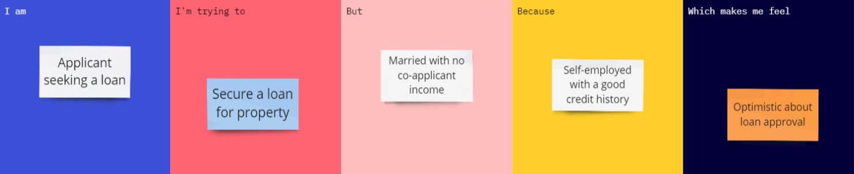

Problem  Statement  (PS) | I am (Customer) | I’m trying  to | But | Because | Which makes me feel
PS-1 | A farmer seeking optimal crop selection. | Maximize my crop yields and resource efficiency for the upcoming farming season. | I am forced to rely on generalized historical guesswork or intuition. | I lack precise, real-time insights on how my specific soil nutrients (N, P, K) and climate conditions interact. | Uncertain and anxious about potential financial losses and resource waste.

